INSTRUCTIONS FOR USING THE KEPLER FITS v2.0 FILE VStar PLUG IN

This contains instructions for first time use. After that you can skip directly to the URL for the Kepler (or K2) Data Search and Retrieval form in the Mikulsi Archive for Space Telescopes (MAST).

The inputs to the Kepler data Plug in are Kepler light curve .FITS files. It does not use complete Kepler data records or the pixel files. Here’s how you get a Kepler FITS file:

1. Go the Kepler and K2 Science Center: <https://keplerscience.arc.nasa.gov/>

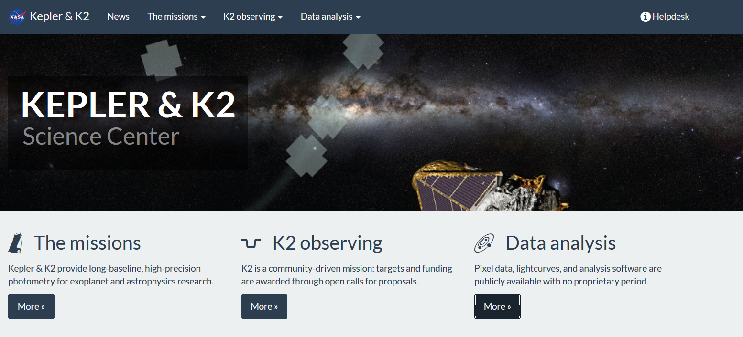

1. On the Data analysis menu pick Data products item to go to the Kepler ad K2 data products page.  
     
   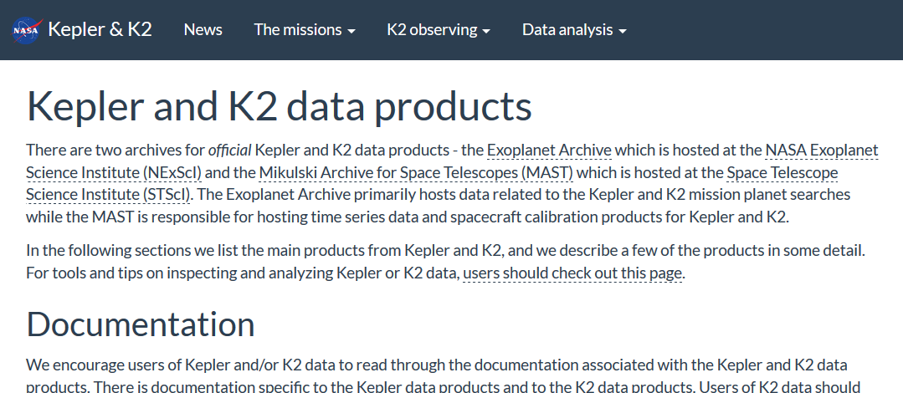
2. At the top of the Kepler product overview section of that page click the link to Kepler mission page at MAST or similarly the K2 mission page at MAST in the K2 product overview section.   
   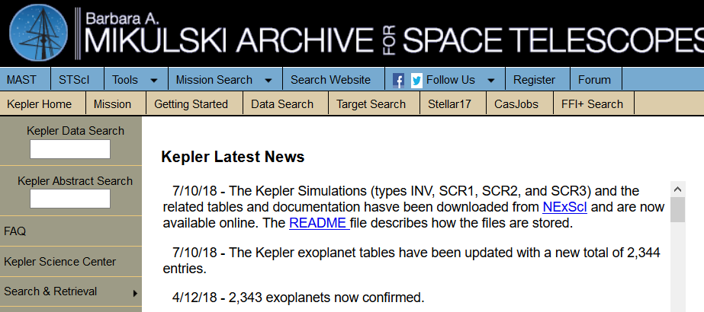  
   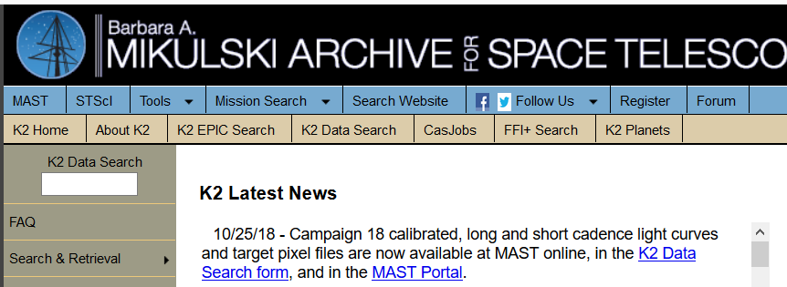
3. Along the left open the Search & Retrieval menu and click the Data Search or K2 Data Search item. The search input form and light curve download procedure will be the same for Kepler and K2 from this point on and only Kepler is shown in this document.
4. 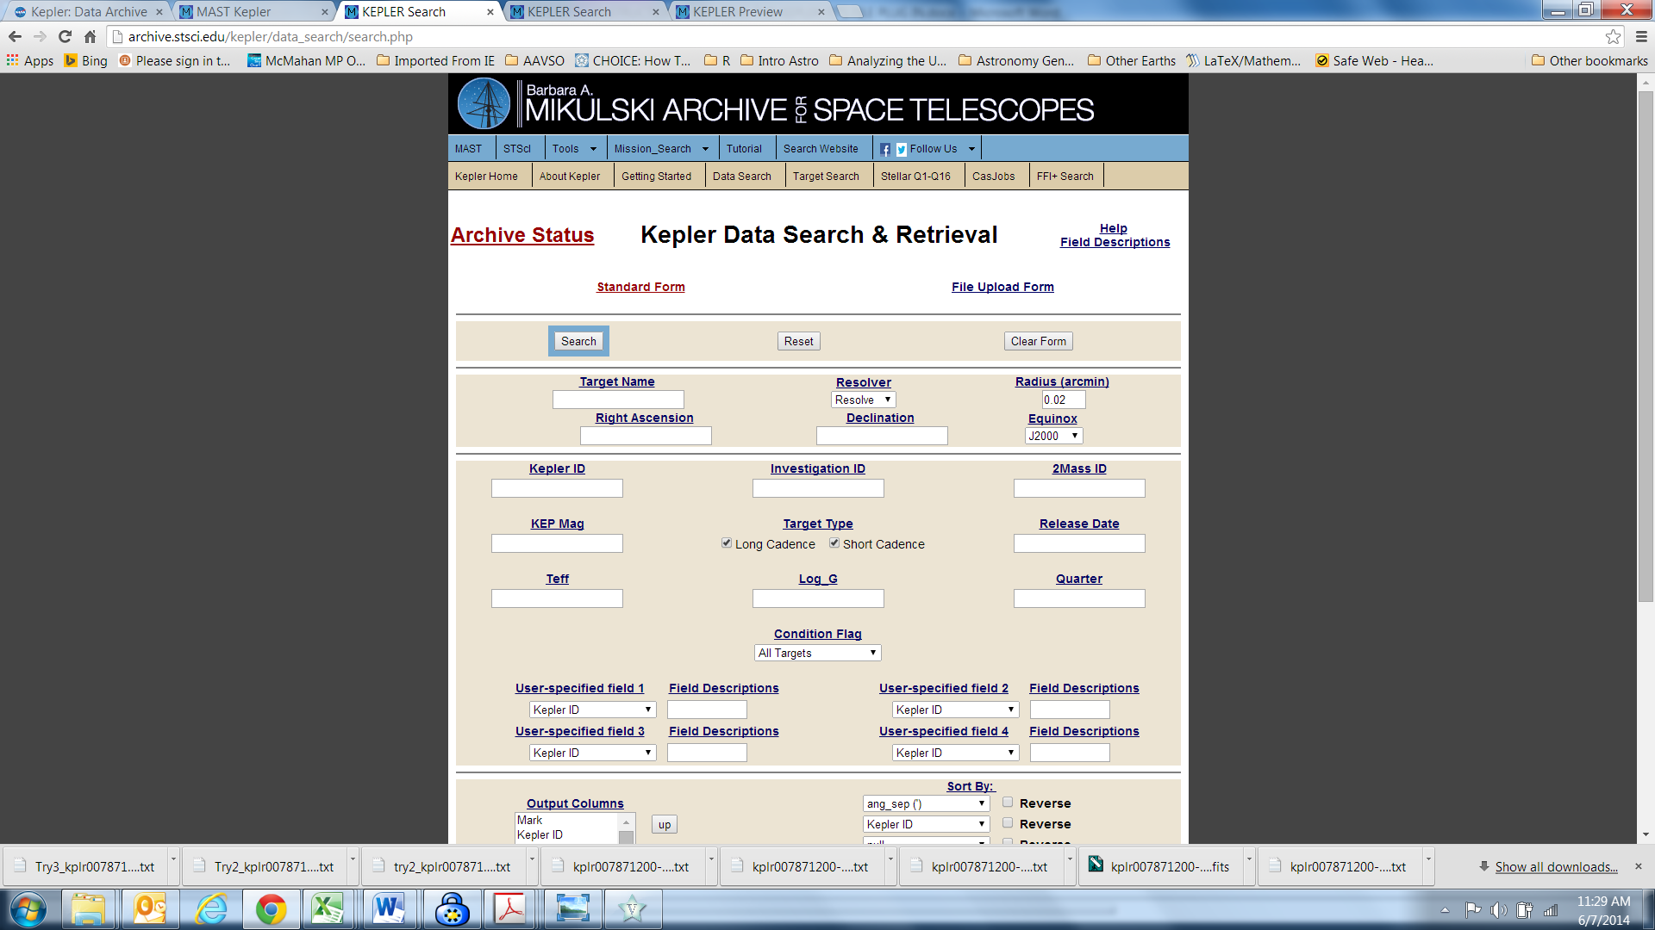  
   MAST data is linked to Simbad. Therefore, you can use most if not all names for an object found in Simbad. You can also use coordinates as the input or Kepler ID numbers and a bunch of other fields and qualifiers to narrow the search. Usually you will just use name or coordinates. You can also customize the information in the output table provided by the search, but since what you are after for input into VStar is the light curve, unless there is specific information about the object that you want in the output table, you will normally use the defaults. Notice in particular the form default will retrieve longs (30 minutes) and short (1 minute) cadence data These are the time periods of the individual 6 and 2/3rds second individual images that were summed on-board into a single equivalent exposure.
5. When you click on the search button at the top of the form or at the bottom (not shown in the image) you will get a summary output table that looks like the following for the eclipsing binary V 579 Lyr:  
   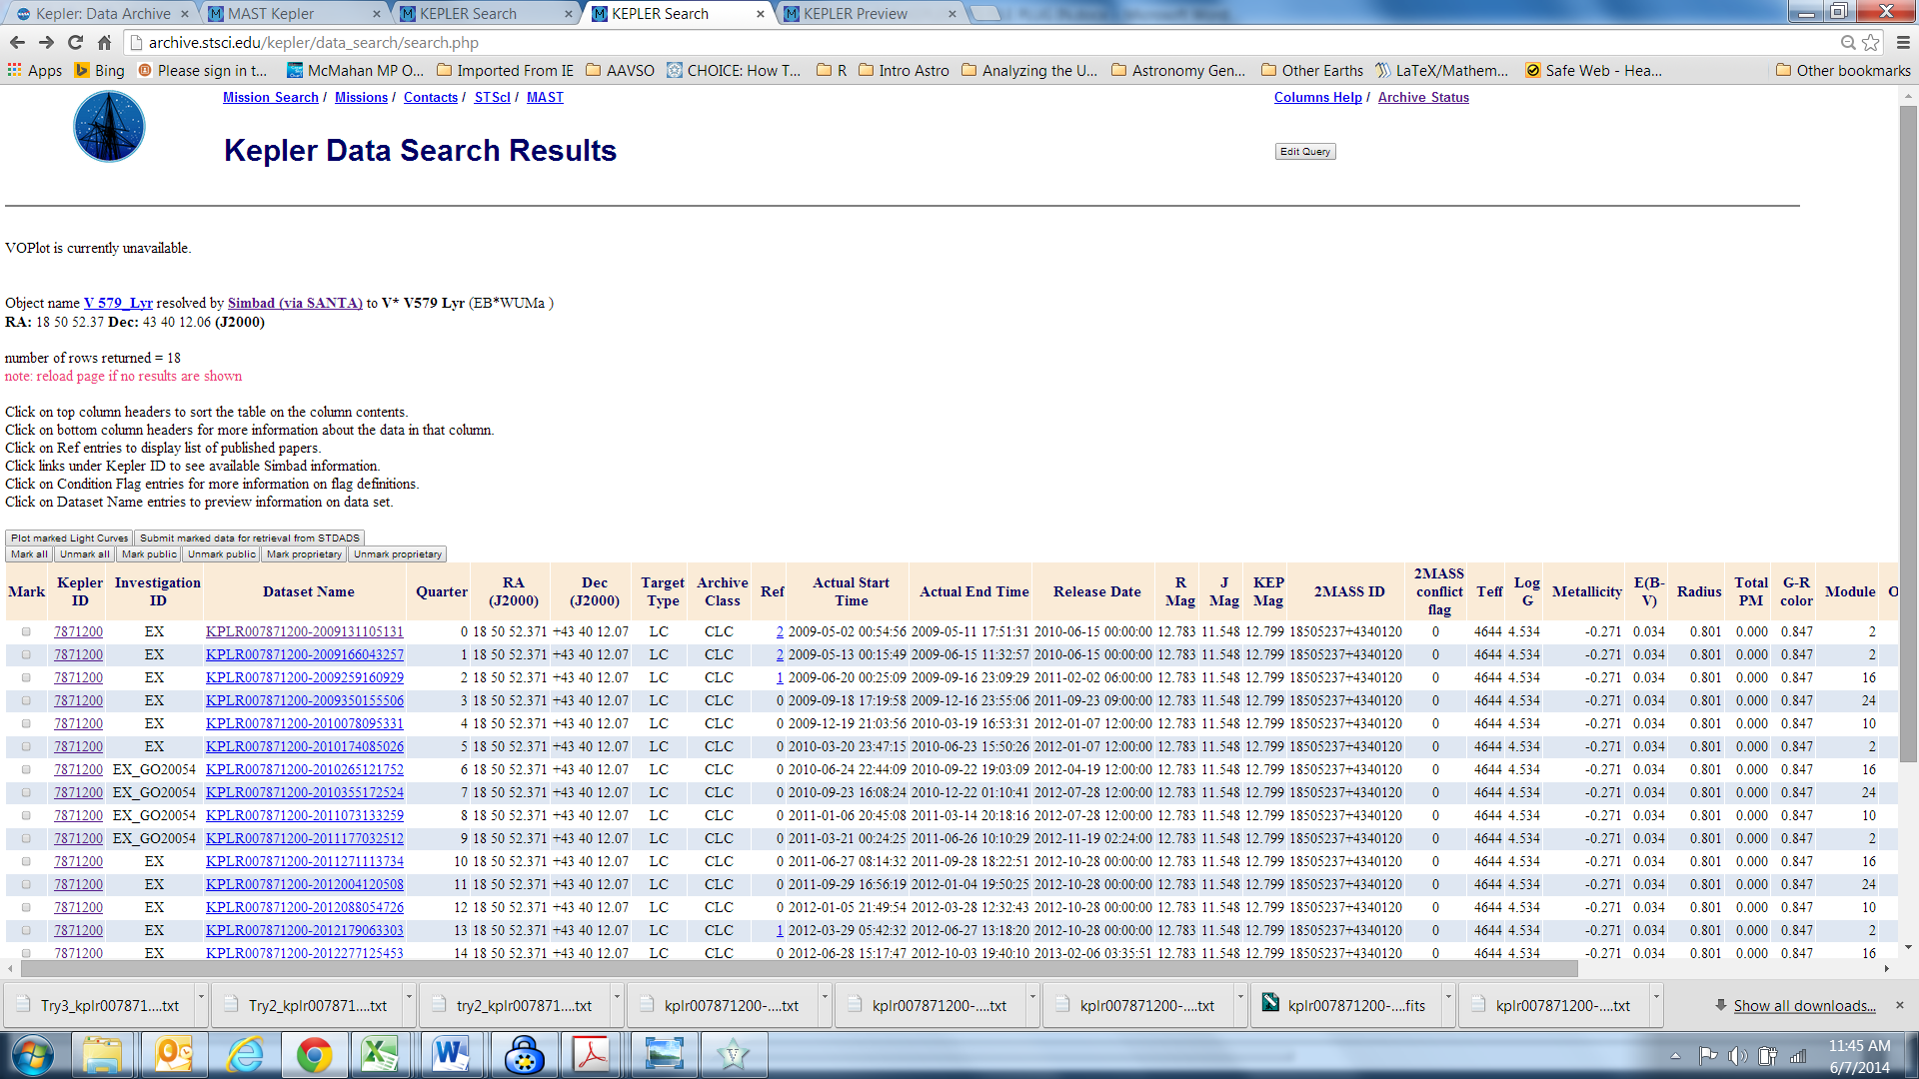
6. Choose the dataset of interest. By default they are listed in increasing order of the quarter in which they were taken. Start and end times of the datasets are shown in other columns. Choose the dataset by clicking on the dataset name. DO NOT USE THE CHECK BOXES IN THE MOST LEFTHAND COLUMN. The column footers (not shown in the image) link to explanations of the terms used in the various columns. For example the Target Type column in the displayed rows tells you that the datasets shown contain long cadence data.   
     
   When you click on the dataset name a preview page opens similar to the following for V 579 Lyr:  
   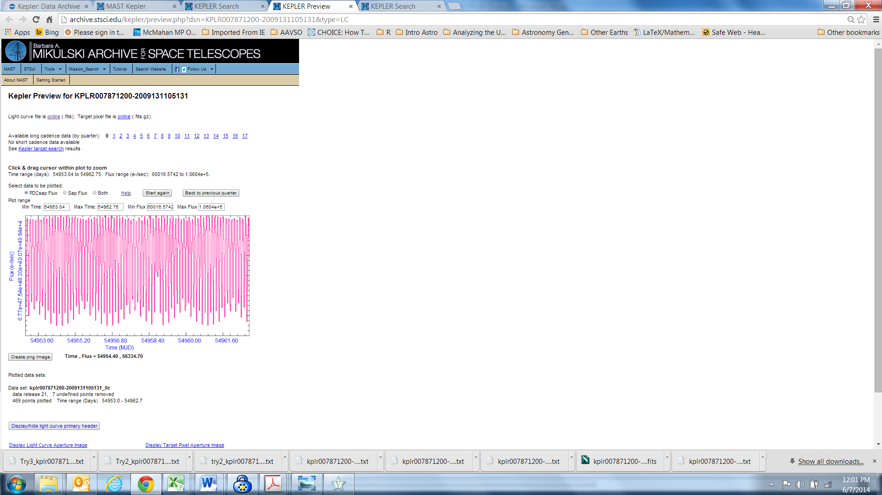  
   When this screen opens the default setting for light curve display is both. SELECT THE BUTTON FOR PDCsap FLUX.1 If you leave the setting as “Both” VStar will give you an error and will not load the data since there are multiple values for each point. PDC stands for Pre-search Data Conditioning that removes systematics from the camera and satellite. If you have a specific reason that you don’t want pre-conditioned data, you can choose the sap Flux button but you cannot leave “Both” selected.   
     
   You will not only see one rather busy light curve rather than two superimposed on each other. Click on the leftmost hot site “online” that is associated with light curve and is identified as “(FITS).”That will open up a text file in your browser. Save the text file. It will have a name that identifies the data set and ends in .fits.txt. You can remove the .txt extension but that step isn’t necessary. The plug in still recognizes it as a Kepler light curve FITS file if the .txt extension remains. You can alter the name of the file preceding the extensions. However, DO NOT OPEN THE FILE WITH A TEXT EDITOR AND RE-SAVE IT. It will probably no longer be a FITS file format and VStar will give you an error when you try to load it.
7. Now comes the easy part. Select New Star From Kepler FITS v2.0 from the file drop down list  
   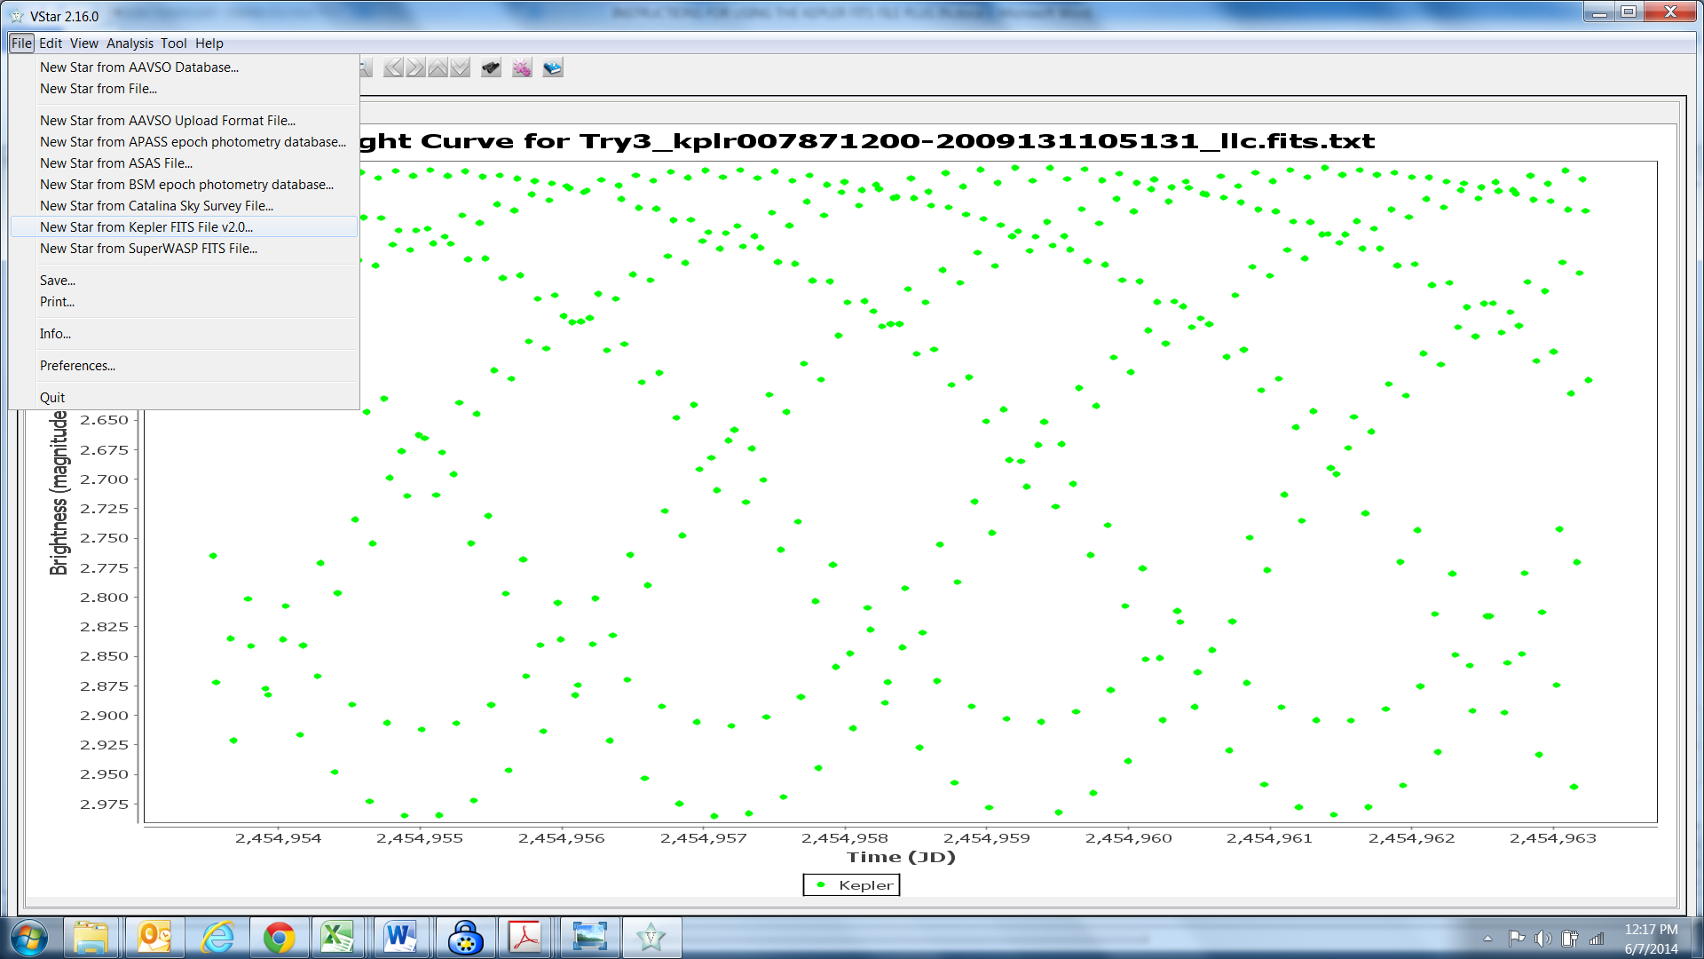
8. Then select the file you saved from Kepler in the normal file browse and select dialog. If you have eliminated the .txt extension, you will have to select all files as the file type. The default shows .txt files but not .fits files.   
   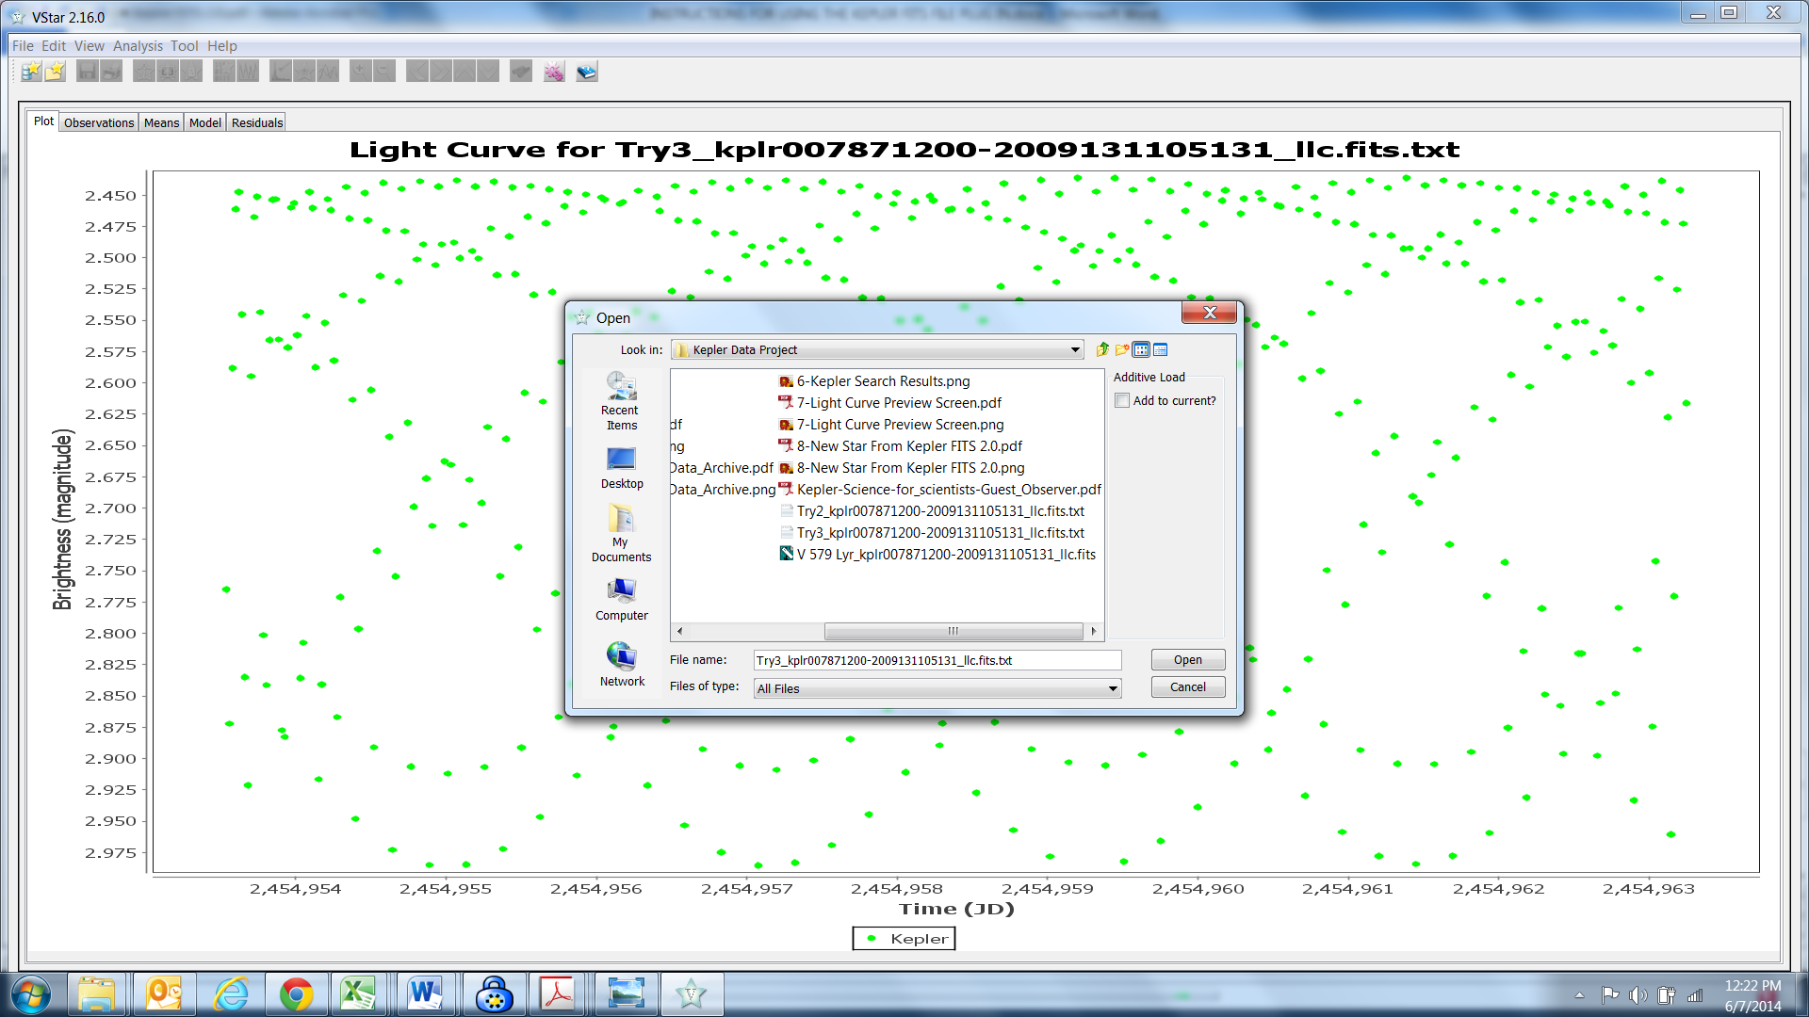
9. If you want to add Kepler Data files together you can use the “Add to Current Check box at the top right of the open file dialog.

Kepler data is NOT restricted to Kepler exoplanet objects of interest. You can find data on essentially any star in the field, certainly any star that was in the Kepler input file. Also ASAS imaged most of the field for about 6 months in 1999 in preparation for the Kepler mission. You can cross index ASAS and Kepler IDs for objects in the field.   
  
There is a wealth of information about the Kepler data sets on the Kepler and MAST websites. If you are going to work with Kepler data two documents that are invaluable are Kepler Data Field Descriptions and the Kepler Archive Manual. Keep in mind that Kepler satellite data is in units of flux. The archive includes flux and magnitude data from follow up sources but caution is needed because the sources have different offsets and are not transformed to a common scale.

Notes:

1. **PDCSAP_FLUX** [32-bit floating point] – The flux contained in the optimal aperture in electrons per second after the PDC module has applied its detrending algorithm to the PA light curve. To better understand how PDC manipulated the light curve, read Section 2.3.1.1 [of the Kepler Archive Manual] and see the PDCSAPFL keyword in the header.

Brad Walter, WBY

Rev E  
20140610

**Revision History**

|  |  |  |
| --- | --- | --- |
| **Rev** | **Date** | **Description** |
| A | 6/7/2014 | Initial Release |
| B | 6/8/2014 | Added item 10 |
| C | 6/9/2014 | Added Footnote 1, changed text in item 10 describing locations of the “Search” buttons and added revision history |
| D | 6/9/2014 | Correct item 10 |
| E | 6/10/2014 | Correct item 7 & add page numbers |
| F | 11/7/2018 | Alter intro to add instruction for either Kepler or K2 (C. Kotnik) |